Project Overview:

The goal of this project is to generate random student feed data into three separate feeds (Feed-1, Feed-2, Feed-3), automate the data generation, identify and cleanse duplicate entries, update data with unique rows, compare feeds, and validate the results. The process is built entirely in SQL Server with automation and testing using SQL.

Requirements:

|  |  |
| --- | --- |
| Req1 | Generate a random data input files a) Feed-1  which has 10 columns with 10 rows, b) Feed-2 which has 15 columns with 15 rows , c) Feed-3 which has 20 columns  with 20 rows |
| Req2 | Automate the Req 1 input file generation using SQL  scripts and the parameter will be "Feed name" & Number of Rows to populate Data |
| Req3 | Write SQL script to identify the duplicate (rows) in each of the table Feed-1, 2, 3 |
| Req4 | Write the duplicate records in output file - "duplicates" |
| Req5 | Create a script to replace all the duplicates with Unique rows and update back to respective Feed table |
| Req6 | Execute the duplicate script and check the output is zero |
| Req7 | Create SQL script to compare data from Feed-2,3 to Feed-1 and write in output file on the compared results |
| Req8 | Create Test plan with all kinds of manual test cases in order to test this End to End functionality |
| Req9 | Automate the test cases (if possible) using any method but should be automated… |
| Req 10 | Document everything in word with all screen grabs as proper Project Document |

**Table of Figures**

Figure 1 : Feed_1 table structure 3

Figure 2: Feed_2 and Feed_3 Table structure 4

Figure 3: Feed_1 Stored Procedure for Data Generation 5

Figure 4: Stored Procedure For Feed_2 Data Generation 6

Figure 5: Stored Procedure For Feed_3 Data Generation 6

Figure 6: Stored Procedure for Feed_3 Part 2 7

Figure 7: Feed_1 Table 9

Figure 8: Feed_2 Data 10

Figure 9: Feed_3 Data with Duplicates Generated 10

Figure 10: Duplicate 1 11

Figure 11: Duplicate_2 12

Figure 12: Duplicate 3 12

Figure 13: Duplicate 3 Data 13

Figure 14: Stored Procedure for Unique Data 14

Figure 15: Checking Duplicates After Insertion of Unique Data 15

Figure 16: Compare Feed_2 to Feed_1 16

Figure 17: Feed 2 and Feed 3 To Feed_1 Comparison Data 16

Figure 18: Save Comparison Data in CSV File Using BCP 17

Figure 19: Test Case For Feed 1 Row and Column Count and Handling Null Value 19

Figure 20: Test Case for Feed_1 and Feed 2 Data Error 20

Figure 21: Feed 3 Testing 20

Figure 22: Feed 3 Duplicate Rows Testing 21

Figure 23: Execution of Test Case Procedure 22

**Feed Specification:**

Student feed generation

Feed_1 : 10 rows and 10 columns

Feed_2 : 15 rows and 15 columns

Feed_3 : 20 rows and 20 columns

**Step 1** : **Student Feed table Creation**

Created tables Feed_1, Feed_2 and Feed_3 and defined the table structure using SQL DDL statements

Feed_1 ( [StudentID] ,[FirstName] ,[LastName] ,[Email] ,[Phone] ,[Gender] ,[DOB] ,[EntryDate] ,[Major] ,[GPA] )

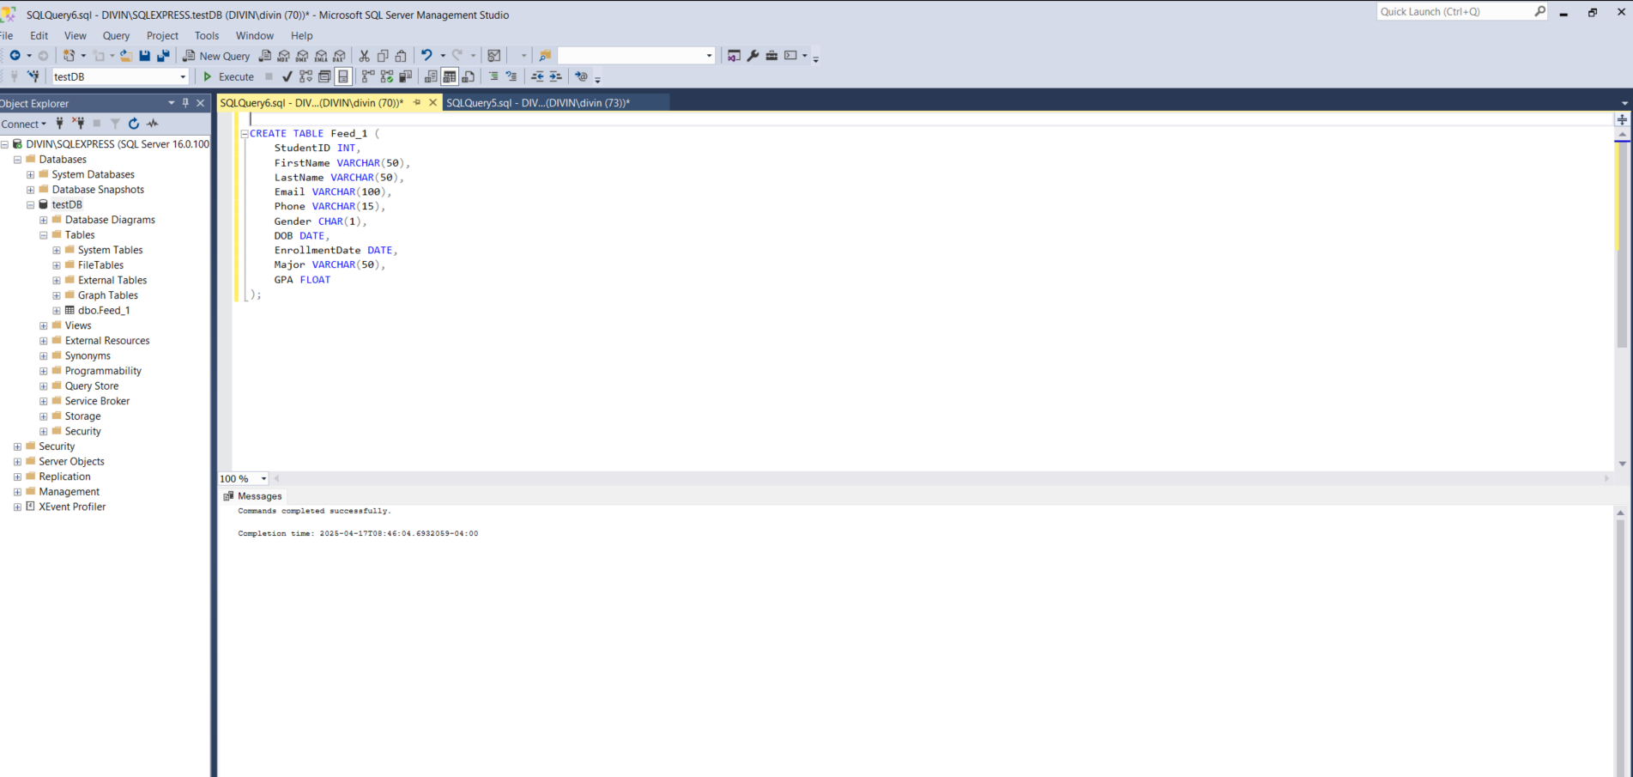

Figure 1 : Feed_1 table structure

Feed_2 ( [StudentID] ,[FirstName] ,[LastName] ,[Email] ,[Phone] ,[Gender] ,[DOB] ,[EntryDate] ,[Major] ,[GPA], [Address] ,[City] ,[State] ,[ZipCode] ,[GuardianName] )

Feed_3 ( [StudentID] ,[FirstName] ,[LastName] ,[Email] ,[Phone] ,[Gender] ,[DOB] ,[EntryDate] ,[Major] ,[GPA] , [Address] ,[City] ,[State] ,[ZipCode] ,[GuardianName] ,[GraduationDate] ,[CreditsEarned] ,[TuitionBalance] ,[IsInternational] ,[Status] )

Figure 2: Feed_2 and Feed_3 Table structure

**Step 2 : Stored procedure for random data generation**

Stored procedures are pre-compiled SQL code that can be executed by name, often accepting input parameters and potentially returning output parameters or result sets.

* Procedure Name : StudentFeed
* Input Parameters:

@FeedName(VARCHAR) : Name of feed

@RowCount(INT): Number of rows to insert

* Key Features:
* Dynamic insertion based on feed type.
* Usage of different functions for realistic data generation.
* All fields are dynamically calculated and generated.

Figure 3: Feed_1 Stored Procedure for Data Generation

Figure 4: Stored Procedure For Feed_2 Data Generation

Figure 5: Stored Procedure For Feed_3 Data Generation

The provided SQL code snippet is designed to insert data into the Feed_3 table. It uses a conditional logic based on the value of the variable @i to populate the table with student data, including some simulated duplicate entries for testing and to fulfill project requirement of displaying duplicate data handling.

Conditional Insertion: The code uses an IF...ELSE IF statement to determine how data is inserted into Feed_3.

* @i <= 16: When @i is less than or equal to 16, the code inserts a set of student records with @i as the primary identifier.
* @i > 16: When @i is greater than 16, the code inserts a set of student records where most of the data is similar to the first 16 records, but with @i - 16 used in the data generation. This creates a set of duplicate records, but with a different primary key.

Figure 6: Stored Procedure for Feed_3 Part 2

Code snippet of @i>16 for feed_3 condition is written to generate a dataset that includes a set of duplicate data which could be useful for testing and handling the duplicate record.

After writing and running Script for data generation as a stored procedure with FeedName and RowCount as input parameters.

**EXEC StudentFeed FeedName, RowCount** command executes a stored procedure named “StudentFeed” to generate data in the Feed_1, Feed_2, and Feed_3 tables, passing the values 10, 15, and 20, respectively, as the number of rows to be generated for each table.

* **EXEC (or EXECUTE)**: This is a SQL command used to run a stored procedure or a string containing dynamic SQL.
* **StudentFeed**: This is the **name of the stored procedure** that is being called.
* FeedName and RowCount are parameters passed

Figure 7: Feed_1 Table

Figure 8: Feed_2 Data

Figure 9: Feed_3 Data with Duplicates Generated

**Step 3: Check for duplicates**

The SQL code identifies and extracts duplicate records from the feed_1 table and stores those duplicates in a new table called duplicate_feed1.

Figure 10: Duplicate 1

The code efficiently identifies records in the feed_1 table that have duplicate values across the FirstName, LastName, Email, Phone, DOB, and Major columns. It then creates a new table, duplicate_feed1, containing only these duplicate records.

CTE common table expression is used to create a temporary view (duplicate_1) with row number with partitioning by FirstName, LastName, Email, Phone, DOB, and Major columns and finding duplicates by filtering the temporary view by row number.

Feed_1 shows zero rows affected since there are no duplicates in the table.

The same process is followed with Feed_2 and Feed_3 and duplicates found are moved into new tables named duplicate_2 and duplicate_3.

Figure 11: Duplicate_2

Figure 12: Duplicate 3

Feed_3 had 4 duplicates and It gets added to the new file duplicate_3

Figure 13: Duplicate 3 Data

**Step 4: Replacing duplicates with unique values**

To replace duplicates with unique values, the duplicates must first be removed using a **DELETE FROM table_name WHERE** condition statement. In this script, data is deleted from the Duplicates_3 temporary view where the row number is greater than 1, and new unique values are inserted using a stored procedure.

Figure 14: Stored Procedure for Unique Data

Unique rows for Feed_3 are inserted using the standard data generation script, with data fields dynamically calculated based on the passed parameter @i. This script generates new data after the 16th row because the StudentFeed data generation procedure adds unique rows to Feed_3 only up to the 16th row ( reference Figure 6).

After insertion of the new unique rows, the Duplicates_3 script is run to confirm that no more duplicates exist, as shown in Figure 15."

Figure 15: Checking Duplicates After Insertion of Unique Data

**Step 5: Feed Comparison**

Compared data from Feed_2 and Feed_3 to Feed_1 using common fields by JOIN statement. SQL code provided below is used to find rows in Feed_2 and Feed_3 that do not have matching row in Feed_1 based on StudentID.

Feed_2 is compared with Feed_1 and 5 affected row data is moved into FEED2_TO_1 new table.

Figure 16: Compare Feed_2 to Feed_1

Figure 17: Feed 2 and Feed 3 To Feed_1 Comparison Data

Figure18: Compare Feed_3 To Feed_1

Figure 18 shows the SQL script used to compare the Feed_3 table to Feed_1. Feed_3 contains 20 rows of data, while Feed_1 has 10 rows. Therefore, the data from StudentID 11 to 20, which is not present in Feed_1, is moved into Feed3_to_1 (affecting 10 rows).

Figure 18: Save Comparison Data in CSV File Using BCP

BCP (Bulk Copy Program) is a command-line utility in SQL Server that is commonly used to export large amounts of data to a file. It can be very efficient for this purpose. To export the data to a CSV file, you would typically use a BCP command with the following options:

* out: Specifies that you are exporting data.
* <filename>.csv: Specifies the name of the CSV file you want to create.
* -c: Specifies that the data should be exported in character format.
* -t,: Specifies the comma (,) as the field terminator, which is what separates the values in a CSV file.
* -T : Specifies the authentication method. -T is for a trusted connection (using your Windows credentials).

Figure 19 shows the usage of BCP to save Feed2_to_1 and Feed3_to_1 data as CSV file to Local folder on the PC.

**Step 6: Manual Test Plan for End-to-End Validation**

Project : Student feed Generator

Env : SQL Server

Tools : SSMS

|  |  |  |  |  |
| --- | --- | --- | --- | --- |
|  | Test Case | Input | Expected Result | Test Result |
| 1. | Define Feed_1, Feed_2 and Feed_3 structure with 10 ,15 and 20 columns each | EXEC sp_help (stored procedure help) 'Feed_1',’Feed_2’ and ‘Feed_3’ | Table structure including, Column name, data types and length. | Pass |
| 2. | Generate Feed_1 with 10 rows | Execute Stored procedure by passing table name as Feed_1, and row count 10 | Table Feed_1 has 10 rows with 10 columns | Pass |
| 3. | Generate Feed_2 with 15 rows | Feed_2, 15 | Table Feed_2 has 15 rows with 15 columns | Pass |
| 4. | Generate Feed_3 with 20 rows | Feed_3, 20 | Table Feed_3 has 20 rows with 20 columns | Pass |
| 5. | |  | | --- | | Validate data types for each column | | Select statement | All columns match expected data types | Pass |
| 6. | Check for duplicates using Script | Feed_1, Feed_2, Feed_3 | Outputs duplicate records | Pass |
| 7. | Clean duplicates using script | Delete duplicates and replace with unique records | Table updated with unique records only | Pass |
| 8. | Re-run duplicate check script | Feed_1, Feed_2, Feed_3 | Duplicate count = 0 | Pass |
| 9. | Compare Feed_2 and Feed_3 to Feed_1 | Match on common columns | Outputs differences | Pass |
| 10. | Generate CSV/Excel from results | Bulk copy program (BCP) using Cmd | CSV files contain expected content | Pass |

**Step 7: Automate test cases**

Figure 19: Test Case For Feed 1 Row and Column Count and Handling Null Value

Figure 20: Test Case for Feed_1 and Feed 2 Data Error

Figure 21: Feed 3 Testing

Figure 22: Feed 3 Duplicate Rows Testing

Figure 19 to 22 are the parts of Testing Procedure script, It performs Automated unit testing for Student data feed (Feed_11, Feed_2 and Feed_3) to validate row counts, column counts, data errors and duplicates.

* Schema Validation:
* Confirms that each feed has the correct number of columns.
* Verifies that the correct number of rows were inserted.
* Data Quality Checks:
* Looks for NULL values in LastName or StudentID.
* Ensures email format has an “@” .
* Validates phone numbers have exactly 10 digits (excluding hyphens).
* Duplicate Detection:
* Groups rows by all key columns (StudentID, FirstName, etc.) and checks for duplicates.

Figure 23: Execution of Test Case Procedure

All test cases passed with PASS status in SSMS message window.

**Summary:**

The Student Feed generation and validation project demonstrates a fully automated, scalable data pipeline using Microsoft SQL Server. Randomized feed creation, integrity validation, duplicate handling, and automated testing—were all achieved within a modular and reusable architecture.

The solution ensures data quality by including checks for nulls, format discrepancies, and duplicates. Test automation through stored procedures enables rapid regression testing, increasing confidence in the integrity of generated feeds. All tests passed successfully, confirming that the system performs accurately across diverse scenarios.